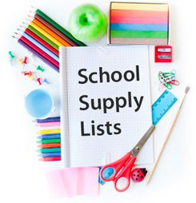

School Supply List Kempner High School Crowson-Wagner

# Ms. Crowson Wagner Supply List

3 – Composition notebooks (black and white- no spiral) 1 - pair of scissors 1 - box of #2 pencils (12pack) 1 - Plastic pencil box that snaps shut 3 - box of colored pencils

12 - Glue sticks 1 - pink eraser

2 – construction paper (8.5x11) 2 - boxes of Kleenex

1 – pack of expo markers 2 – Hand sanitizer

*3 – Wet wipes